LAB REPORT实验报告
Lab Title | Calculator |  |  |  | Lab No.
Stud. Name | 蒋云翔 | Major | CST |  | Class
Student ID | 2022102330 |  | Date | 2023/10/31
Lab description/objectives:
For this project, you will design and implement a simple integer calculator, which
converts infix expressions to postfix expressions and evaluates the postfix expressions.
Graphical interface is not required. Calculator input will be provided from the
keyboard and feedback from the calculator application will be displayed on the
screen.
Inputted infix expressions will contain only operands, operators and parenthesis,
where
- An operand is a sequence of one or more decimal digits, optionally preceded by a
plus or minus sign, and containing no embedded spaces or tabs.
- Operators include the characters +, -, *, /, ( and ).
Your design should have some fault tolerance. For example in the input expression
there could be some illegal numerical operations (division by zero) or unbalanced
symbols. Your program must deal with these situations without crashing. If an error
occurs, your program should print out an error message, flush the current expression
and proceed to the next input command.
#include <stdio.h>
#include <stdlib.h>
#include <ctype.h>
#define MAX 100

// 定义栈节点（按project要求使用链表形式！！）
typedef struct StackNode {
int data;
struct StackNode* next;
} StackNode;

// 定义栈
typedef struct Stack {
StackNode* top;
} Stack;

// 创建新栈节点
StackNode* create_node(int data) {
StackNode* new_node = (StackNode*)malloc(sizeof(StackNode));
new_node->data = data;
new_node->next = NULL;
return new_node;
}

// 判断栈是否为空（通过栈顶是否为空来判断）
int is_empty(Stack* stack) {
return stack->top == NULL;
}

// 将一个元素push到栈中
void push(Stack* stack, int data) {
StackNode* new_node = create_node(data);
new_node->next = stack->top;
stack->top = new_node;
}

// 从栈中pop一个元素（与下面的自定义函数peek()做对比，这里的pop会把栈顶元素free掉）
int pop(Stack* stack) {
if (is_empty(stack)) {
printf("Error message: Stack underflow!!!\n"); //栈下溢！！
exit(1);//退出程序
}
int data = stack->top->data;
StackNode* temp = stack->top;
stack->top = stack->top->next;
free(temp);
return data;
}

// 返回栈顶元素的值，但不修改栈（方便做符号优先级检验）
int peek(Stack* stack) {
if (is_empty(stack)) {
return -1;
}
return stack->top->data;
}

// 判断一个字符是否为数字（使用ctype.h头文件里面的isdigit函数来判断）
int is_digit(char c) {
return isdigit(c) != 0;
}

// 计算两个操作数的结果
int calculate(int operand1, int operand2, char operator) {
switch (operator) {//使用switch语句来进行筛选计算
case '+':
return operand1 + operand2;
case '-':
return operand1 - operand2;
case '*':
return operand1 * operand2;
case '/':
if (operand2 == 0) {
printf("Error message: Division by zero\n");
return 0;// 此处没有用exit()函数来退出程序，满足project刷新表达式并重新读取用户输入的需求
}
return operand1 / operand2;
default:
printf("Error message: Invalid operator\n");
exit(1);
}
}

int get_precedence(char operator) { //给operator定义大小，以此作为优先级的判断，方便从栈里push和pop符号
switch (operator) {
case '+':
case '-':
return 1;
case '*':
case '/':
return 2;
default:
return -1;
}
}

// 将中缀表达式转换为后缀表达式
void InfixToPostfix(char* infix_expression, char* postfix_expression) {
Stack operator_stack;
operator_stack.top = NULL;

int i = 0;
int j = 0;
while (infix_expression[i] != '\0') {
if (is_digit(infix_expression[i])) {
postfix_expression[j++] = infix_expression[i]; //继续往下读取，如果遇到数字则继续push
while (is_digit(infix_expression[++i])) {
postfix_expression[j++] = infix_expression[i];
}
postfix_expression[j++] = ' ';
i--;
}
else if (infix_expression[i] == '+' || infix_expression[i] == '-' || infix_expression[i] == '*' || infix_expression[i] == '/') {
int precedence = get_precedence(infix_expression[i]); //获取operator的优先级
while (!is_empty(&operator_stack) && peek(&operator_stack) != '(' && precedence <= get_precedence(peek(&operator_stack))) {
postfix_expression[j++] = pop(&operator_stack);
postfix_expression[j++] = ' ';
}
push(&operator_stack, infix_expression[i]);
}
else if (infix_expression[i] == '(') {//以下是对于括号的符号判断
if (is_digit(infix_expression[i - 1])) {//此情况是：左括号的左边是一个operand而非一个operator！！
printf("Error message:invalid infix expression\n");
exit(1);
}
push(&operator_stack, infix_expression[i]);
}
else if (infix_expression[i] == ')') {
if (infix_expression[i - 1] == '('){
printf("Error message: Unmatched parentheses\n"); //此情况是：括号内没有任何东西！！
exit(1);
}
while (!is_empty(&operator_stack) && peek(&operator_stack) != '(') {
postfix_expression[j++] = pop(&operator_stack);
postfix_expression[j++] = ' ';
}
if (!is_empty(&operator_stack) && peek(&operator_stack) == '(') {
pop(&operator_stack);
}
else {
printf("Error message: Unmatched parentheses\n");
exit(1);
}
}
i++;
}

while (!is_empty(&operator_stack)) {
if (peek(&operator_stack) == '(') {
printf("Error: Unmatched parentheses\n"); //此情况是：还有左括号没有被取出来，括号数量不匹配！！
exit(1);
}
postfix_expression[j++] = pop(&operator_stack);
postfix_expression[j++] = ' ';
}
postfix_expression[j] = '\0';
}

// 计算后缀表达式的值
int Calculator(char* postfix_expression) {
Stack operand_stack;
operand_stack.top = NULL;

int i = 0;
int operand, operand1, operand2, result;
int is_division_by_zero = 0; // 用于辅助判断是否出现除数为0的情况
while (postfix_expression[i] != '\0') {
if (is_digit(postfix_expression[i])) {
operand = 0;//设置此变量，用于连续读取数字，将其转变为对应的位数
while (is_digit(postfix_expression[i])) {
operand = operand * 10 + (postfix_expression[i] - '0'); //每次多取一位进来，就说明第一次取得数要进一位，在十进制中进一位是*10，因此此处乘了10来进位。
i++; //而后面的 -'0'的目的是将char类型的数据转变为int类型。
}
push(&operand_stack, operand);
i--;
}
else if (postfix_expression[i] == '+' || postfix_expression[i] == '-' || postfix_expression[i] == '*' || postfix_expression[i] == '/') {
operand2 = pop(&operand_stack);
operand1 = pop(&operand_stack);
if (postfix_expression[i] == '/' && operand2 == 0) { // 出现除数为0的情况
printf("Error message: Division by zero\n");
is_division_by_zero = 1;
break; // 直接退出循环
}
result = calculate(operand1, operand2, postfix_expression[i]);
push(&operand_stack, result);
}
i++;
}

if (is_division_by_zero) { // 如果出现除数为0的情况，清空操作数栈，重新读取用户输入
while (!is_empty(&operand_stack)) {
pop(&operand_stack);
}
return 0;
}
else { // 否则返回最终结果
return pop(&operand_stack);
}
}

int main() {
char infix_expression[MAX];
char postfix_expression[MAX];
int result;

while (1) {
printf("Enter an infix expression (or 'q' to quit): ");
fgets(infix_expression, MAX, stdin);
if (infix_expression[0] == 'q') {
break;
}

InfixToPostfix(infix_expression, postfix_expression);
printf("Postfix expression: %s\n", postfix_expression);

result = Calculator(postfix_expression);
printf("Result: %d\n", result);
}

return 0;
}
Program outputs:
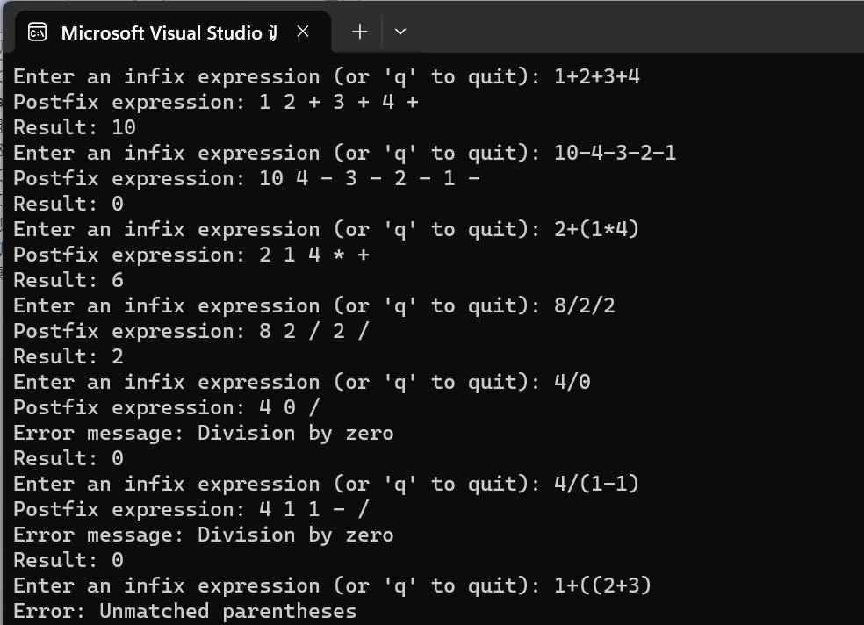
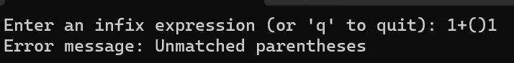
Analysis and Comments：
Analysis part：
- There are some situations that will lead the error:
①Division by 0;
②The char data stored in the stack behind the left parenthesis is not a operator but a operand;
③There is nothing inside a parenthesis;
④Unmatched parentheses: The number of the parentheses are not matched

Comments:
The most imperious ingenious part of this program is the function that continuously read numbers and operates it by multiply 10, just like the same operations in the binary number: left shift means multiply 2 to the number;

